BEA Biennial Conference Accommodation (Guide Only)

Melbourne is a vibrant city with many options for accommodation. To help you select VCTA has put together a short list of accommodation venues within walking distance to the conference that are offering discounted rates for BEA delegates. Please check with your own loyalty programs and preferred accommodation suppliers before you book with one of the recommended options below.

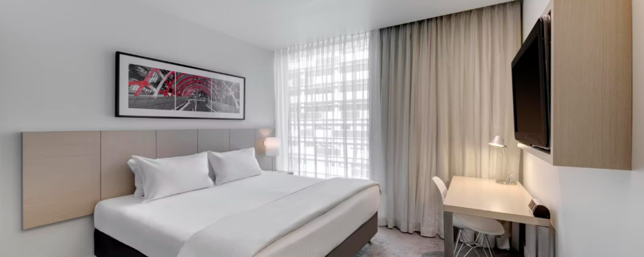
Travelodge Hotel Docklands (250 metre walk to conference venue)
Address: 66 Aurora Lane, Docklands, VIC 3008
Phone: 1300 886 886
Book Now
20% off best available rate from
16-20 June, 2026.
Exclusive to BEA Delegates Only.
Hotel is accessible via a laneway and has both lift and stair access. Small kitchenette in most rooms. Restaurant onsite at additional cost. This is a budget option for the savvy conscience traveller.

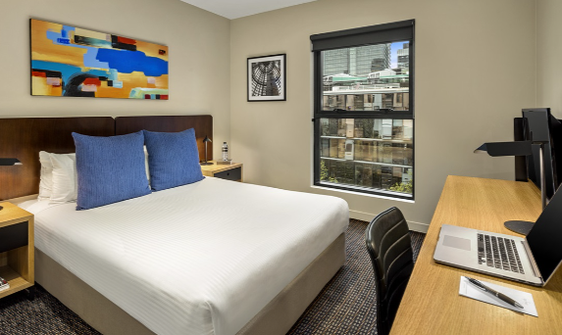
Quest Docklands (350 metre walk to conference venue)
Address: 750 Bourke Street, Docklands, VIC 3008
Phone: 03 9630 1000
Enter promo code: BEA2026
The promo code covers dates:
16-21 June, 2026.
Exclusive to BEA Delegates Only.
All rooms have a kitchen or kitchenette. Pantry Shopping Service available. No onsite restaurant.

Oaks on Market (1.1 km walk to conference venue or free tram ride along Collins Street)
Address: 60 Market Street, Melbourne, VIC 3000
Phone: 13 62 57
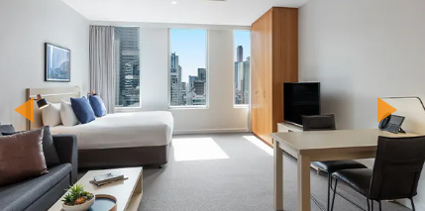
Exclusive Promo for Delegates: Send an email to the front desk: Market@theoaksgroup.com.au and copy Chamali Weerarathna ev1market@theoaksgroup.com.au requesting the special rates for the BEA Conference ($219 per night)
17-20 June, 2026.
Exclusive to BEA Delegates Only.
All rooms have a kitchen or kitchenette, living area, bath in bathroom. Onsite restaurant and bar, gym and pool.

